The 14 Leadership Principles that Drive Amazon

[**Ian Golding**](http://customerthink.com/author/ijgolding/)

July 6, 2017

[6](http://customerthink.com/the-14-leadership-principles-that-drive-amazon/#comments)

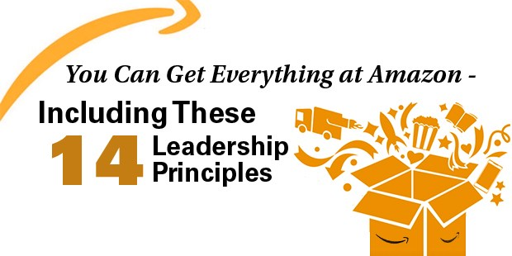

Over the last five years, a small number of organizations have featured multiple times in my writing. In the vast majority of cases, I have used these businesses as a way of bringing to life global best practice in the field of Customer Experience Management. It is inspiring to be able to share insight and ideas from those who have been able to take the principles of Customer Experience and firmly embed them into the very fabric of  the way their companies work.

The company I have perhaps mentioned more than most is Amazon. Not only am I a regular customer of the global retail giant, I am also a huge fan of the man who founded the company. Only recently, I wrote about Jeff Bezos and why I believe he is a, if not the, [role model customer centric leader](https://ijgolding.com/2017/05/18/role-model-customer-centric-leadership-i-huge-fan-jeff-bezos/).

I am always overjoyed when others read my ‘ramblings’, adding their thoughts, perspectives, opinions and insight to the topics I feature. A good friend of mine read the Jeff Bezos article and contacted me shortly afterwards. ‘Did you know that Amazon have actually embedded 14 leadership principles into the way they work?’, was the question posed to me. I did not. As I say on a daily basis – one of the wonderful things about specialising in a subject, is that I never stop learning more about it. For reasons unbeknown to me, the fact that Amazon have 14 leadership principles had completely passed me by.

What my friend brought to my attention is fascinating – and goes a very long way to explaining why and how Jeff Bezos has been able to create such a strong customer centric culture in his business. If you have never heard about or seen these principles before, I am sure you will find them fascinating AND inspiring as well – here they are…

1. **Customer Obsession**  
   Leaders start with the customer and work backwards. They work vigorously to earn and keep customer trust. Although leaders pay attention to competitors, they obsess over customers.
2. **Ownership**  
   Leaders are owners. They think long term and don’t sacrifice long-term value for short-term results. They act on behalf of the entire company, beyond just their own team. They never say “that’s not my job.”
3. **Invent and Simplify**  
   Leaders expect and require innovation and invention from their teams and always find ways to simplify. They are externally aware, look for new ideas from everywhere, and are not limited by “not invented here”. Because we do new things, we accept that we may be misunderstood for long periods of time.
4. **Are Right, A Lot**  
   Leaders are right a lot. They have strong judgement and good instincts.  They seek diverse perspectives and work to disconfirm their beliefs.
5. **Learn and Be Curious**  
   Leaders are never done learning and always seek to improve themselves. They are curious about new possibilities and act to explore them.
6. **Hire and Develop the Best**  
   Leaders raise the performance bar with every hire and promotion. They recognise people with exceptional talent and willingly move them throughout the organisation. Leaders develop leaders and are serious about their role in coaching others.  We work on behalf of our people to invent mechanisms for development like Career Choice.
7. **Insist on the Highest Standards**  
   Leaders have relentlessly high standards – many people may think these standards are unreasonably high. Leaders are continually raising the bar and driving their teams to deliver high quality products, services and processes. Leaders ensure that defects do not get sent down the line and that problems are fixed so they stay fixed.
8. **Think Big**  
   Thinking small is a self-fulfilling prophecy. Leaders create and communicate a bold direction that inspires results. They think differently and look around corners for ways to serve customers.
9. **Bias for Action**  
   Speed matters in business. Many decisions and actions are reversible and do not need extensive study. We value calculated risk taking.
10. **Frugality**  
    Accomplish more with less. Constraints breed resourcefulness, self-sufficiency and invention.  There are no extra points for growing headcount, budget size or fixed expense.
11. **Earn Trust**  
    Leaders listen attentively, speak candidly, and treat others respectfully. They are vocally self-critical, even when doing so is awkward or embarrassing.  Leaders do not believe their or their team’s body odour smells of perfume.  They benchmark themselves and their teams against the best.
12. **Dive Deep**  
    Leaders operate at all levels, stay connected to the details, audit frequently, and are sceptical (skeptical) when metrics and anecdote differ. No task is beneath them.
13. **Have Backbone; Disagree and Commit**  
    Leaders are obligated to respectfully challenge decisions when they disagree, even when doing so is uncomfortable or exhausting. Leaders have conviction and are tenacious. They do not compromise for the sake of social cohesion. Once a decision is determined, they commit wholly.
14. **Deliver Results**  
    Leaders focus on the key inputs for their business and deliver them with the right quality and in a timely fashion. Despite setbacks, they rise to the occasion and never compromise.

I. LOVE. THIS!!! Fourteen leadership principles seems like a lot! However, I think it is extremely difficult to read them and disagree. How many leaders are actually demonstrating all fourteen of these? Not enough in my opinion!

Jeff Bezos is THE role model customer centric leader and is instilling global best practice leadership into the way his organisation works. I am inspired by this – I hope you are too.